

The 5Cs Summer 2013 Report

This summer marked the eighth year that The 5Cs have sent volunteers to the Belarusian Childrens Hospice summer camp in Zabrodia. The camp provides a much needed break for families and children under the care of the Hospice and is run by Hospice staff and a team of international volunteers.

Our volunteers make up part of this international team team that care for children, prepare activities and help with kitchen duties. In addition to these volunteers, The 5Cs also sends a larger group that help with maintenance of the camp, painting, digging and repairing- you name it!

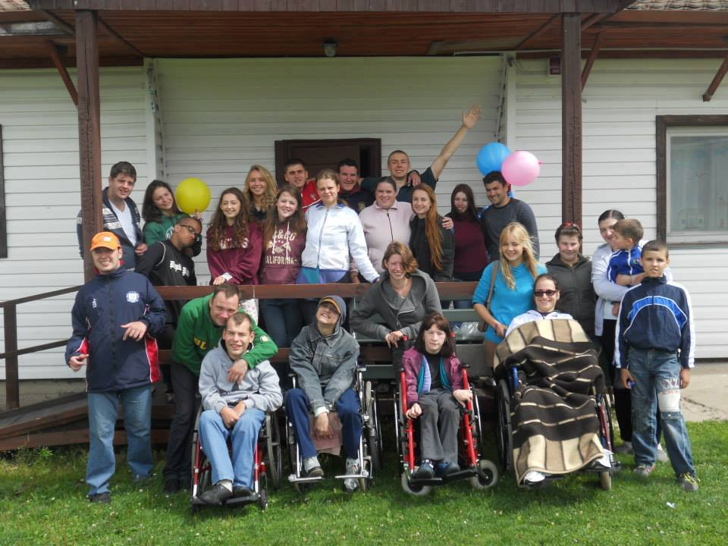Although we are involved in supporting many of the Hospice projects and fundraising to help cover the costs of opening the camp, this volunteer project is the largest programme that The 5Cs run each year. We provide volunteers for each session that the camp is open, a total of five 2 week sessions, this year totalling 30 volunteers over the 10 weeks.

Our volunteers are made up of final year students from local colleges in Cardiff that have applied for the programme for the first time and existing 5Cs members that are experienced volunteers in Zabrodia and are part of the team that run the charity throughout the year. We also have a team of very experienced volunteers that help to select and train new volunteers before they go to Zabrodia and then supervise and manage the project, along with the Hospice staff and volunteer coordinator, while they are there. These supervisors stay in a small house in the village and join in with all camp activities and support all the volunteer team with whatever is needed, whether it be a lift to the shop in the Hospice car that we borrow for the summer or help with preparing the day’s activities- usually involving a song, dance or show- always involving dressing up!

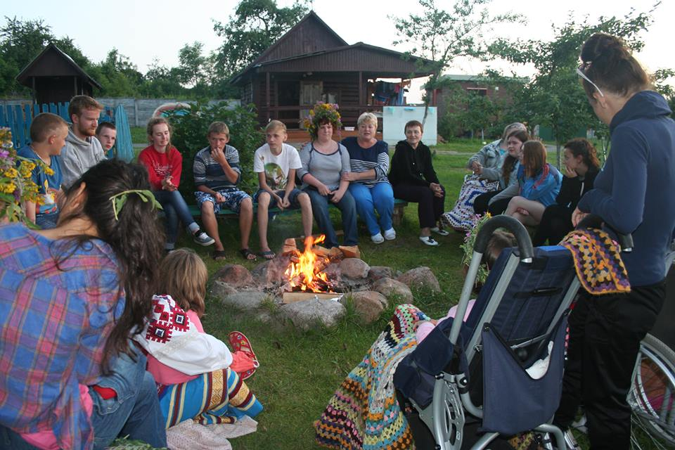This summer the childcare volunteers exceled, helping to care for the children and preparing brilliant activities and games for them. Some of the children that visit the camp need 24 hour care with many aspects of their lives, including showering, toileting and eating. All the volunteers do a great job- most of them with no previous experience, bearing in mind The 5Cs volunteers don’t speak Russian and not many of the children speak English, the way that they find creative ways of communicating and take everything in their stride never fails to amaze us. All of the groups were so close by the end that there were always lots of tears when the bus came to collect everyone to go home!

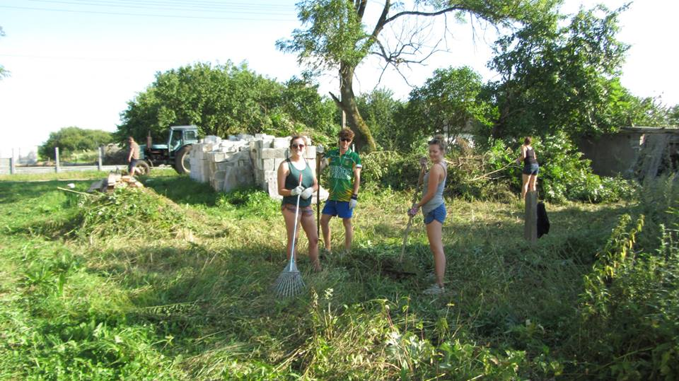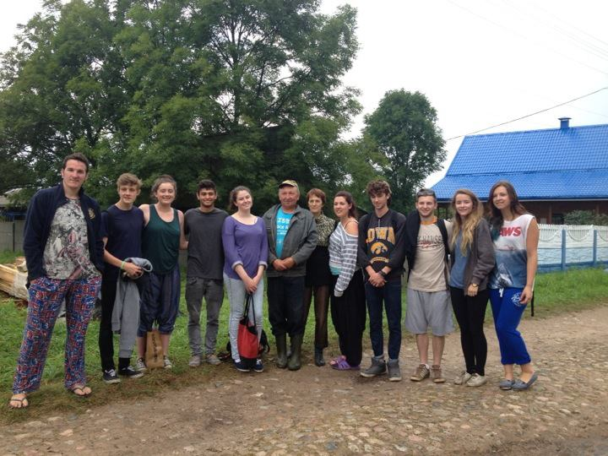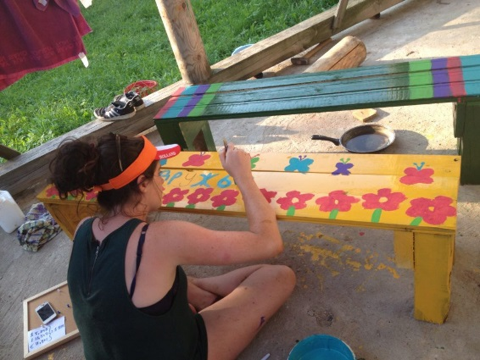This summer the maintenance volunteers had great fun camping in our small house in the village, they were not only able to debark and wood preserve the wooden structures in the Stork Project garden, make colourful benches for the campfire and touch up lots of the paint work to keep the camp looking vibrant, but they were also able to make a start on the clearing of the land next door to the camp that The 5Cs and the Hospice bought last year with the view to expanding the camp. They worked tirelessly in the heat to do as much of the clearing as possible and then the builders took over on their departure, meaning we are able to get the foundations of a new volunteer house built before the winter!

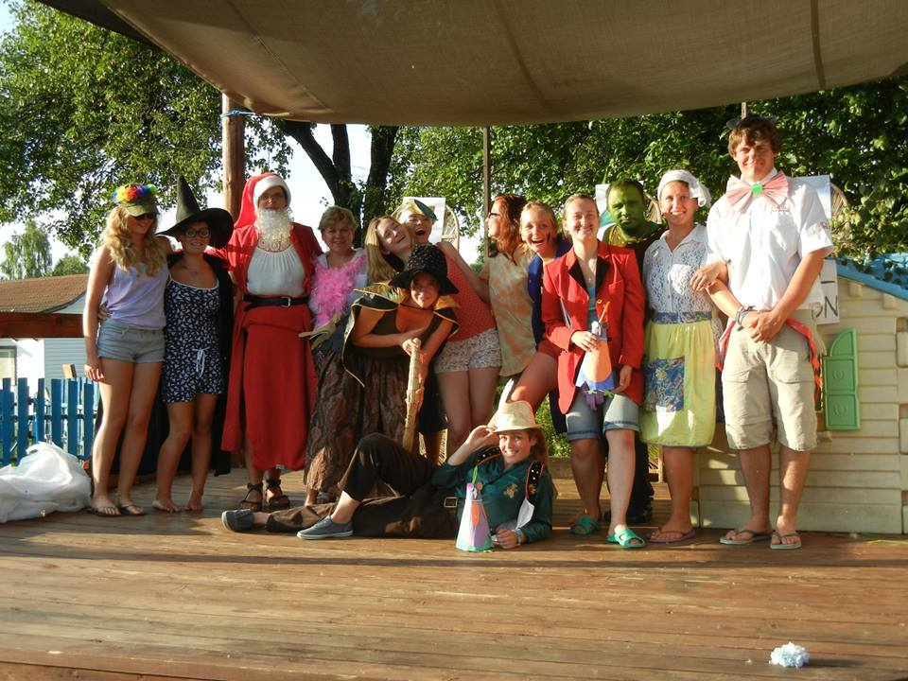The time on the camp for volunteers and children is truly unique, one of our childcare volunteers and 5Cs members describes that her first time on the camp last year “can only be described as the most perspective-altering, attitude-changing experience of my mere 17 years.” We have tried and failed over the years to pinpoint exactly what it is that makes the camp such a special place. We believe it is a combination of the loving, brave and inspirational children that we have the honour of spending time with, along with the creativity, warmth and absolute dedication of the staff and volunteers. We are yet to meet anyone that has stayed at the camp and not been planning their next trip before the end of their session. Volunteers and children alike become singers, dancers, performers, lifelong friends, support networks to each other and so much more. In the words of one of our maintenance volunteers “it appears there’s something unbreakable about the bond of sharing a mosquito net or fetching well-water together.”

As the Hospice grows, with more and more families needing their help, the camp is also growing- and along with it, The 5Cs are growing… for the year 2013-14 we have a total of 53 on the committee made up of 7 trustees, 8 team leaders and 38 members! We feel we are unique as we are run *by* young people….. (40 members of our committee are students and 50 are under 25!)….. *for* young people.

We are very lucky to have a team that are not only enthusiastic and committed to The 5Cs, but also extremely passionate about the Hospice, the camp and the children. We look forward to another great year as The 5Cs family!